Ideation Phase
Define the Problem Statements

Date | 5 Feb 2026
Team ID | LTVIP2026TMIDS74950
Project Name | LearnHub: Your Center for Skill Enhancement
Maximum Marks | 2 Marks

Customer Problem Statement :
Students and educators face challenges in accessing structured, secure, and trackable online learning platforms. Many existing systems lack proper role-based control, payment verification, progress tracking, and automated certification. Course management is often disorganized, and users struggle with insecure authentication and unclear learning pathways. There is a need for a unified, secure, and scalable Learning Management System that simplifies digital education, ensures structured course delivery, and provides verified proof of completion.

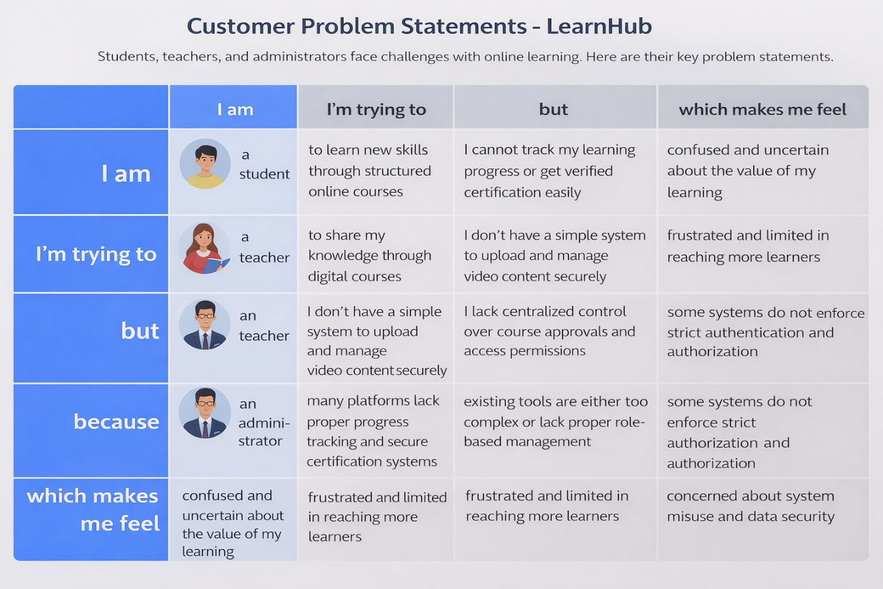

Example:
Problem Statement (PS) | I am (Customer) | I’m trying to | But | Because | Which makes me feel
PS-1 | a student | to learn new skills through structured online courses | I cannot track my learning progress or get verified certification easily | many platforms lack proper progress tracking and secure certification systems | confused and uncertain about the value of my learning
PS-2 | a teacher | to share my knowledge through digital courses | I don’t have a simple system to upload and manage video content securely | existing tools are either too complex or lack proper role-based management | frustrated and limited in reaching more learners
PS-3 | an administrator | to manage users and maintain system security | I lack centralized control over course approvals and access permissions | some systems do not enforce strict authentication and authorization | concerned about system misuse and data security

